JAMIA HAMDARD

DEPARTMENT OF COMPUTER SCIENCE & ENGINEERING

School of Engineering Sciences & Technology



**MCA 107- Object Oriented Programming Lab**

**ASSIGNMENT FILE**

**SUBMITTED TO:** **Dr. Shahab Saquib Sohail Sir**

**SUBMITTED BY:** **Sukaina Inam Naqvi**

**Enrolment no: - JH23-PGP-02037**

MCA- 1st Year |  1st  Semester

INDEX

|  |  |  |
| --- | --- | --- |
| S.no. | Questions | Page no. |
| 1 | Write a program in c++ to perform arithmetic operations with three integer variables. | 3 |
| 2 | Without using third variable, swap the value of two variables. | 5 |
| 3 | Write a program in c++ to print Fibonacci series. | 6 |
| 4 | You are given a number, write a program in c++ to check whether the number is prime or not? | 7 |
| 5 | Write a program in c++ to print ‘*’ (Asterisk) in triangle form. | 8 |

**Question1. Write a program in c++ to perform arithmetic operations with three integer variables.**

**Code:**

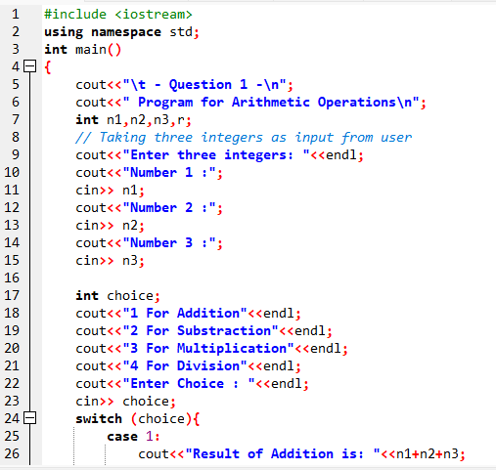

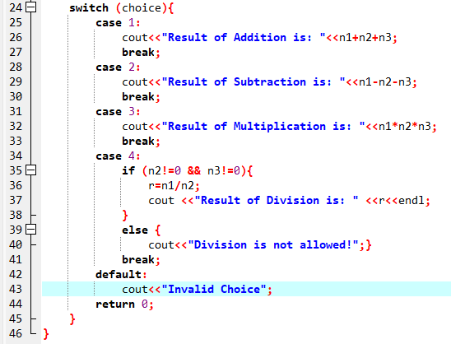

**Output:**

**Addition: Subtraction:**

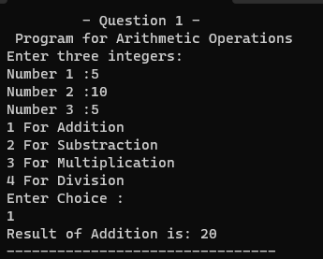 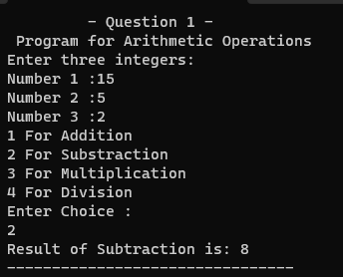

**Multiplication: Division:**

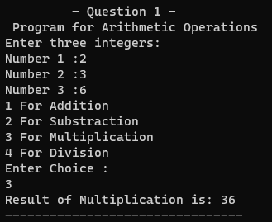 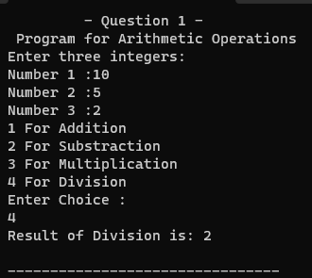

**Question 2. Without using third variable, swap the value of two variables.**

**Code:**

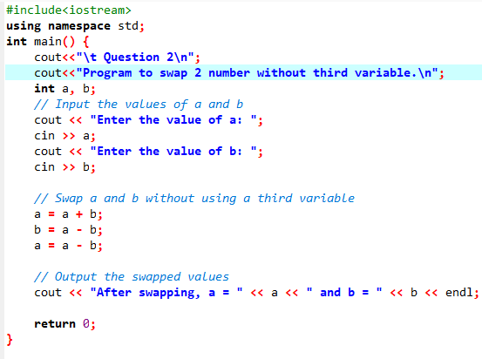

**Output:**

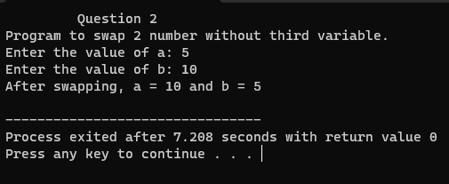

**Question 3. Write a program in c++ to print Fibonacci series.**

**Code:**

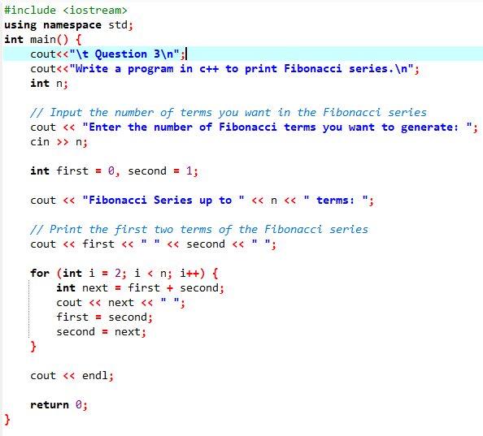

**Output:**

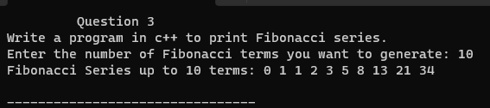

**Question 4. You are given a number, write a program in c++ to check whether the number is prime or not?**

**Code:**

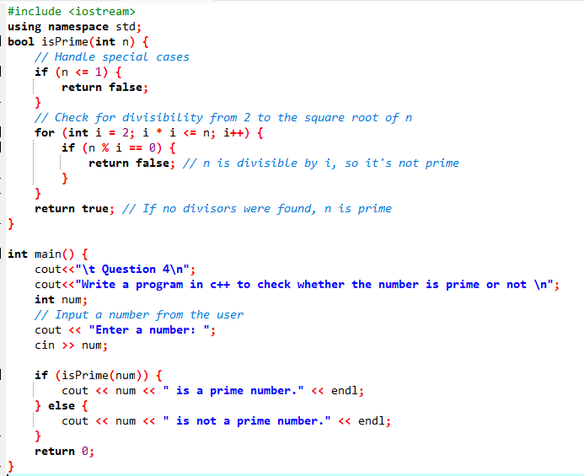

**Output:**

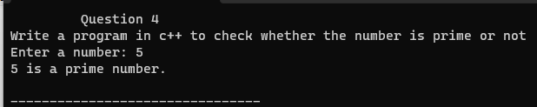

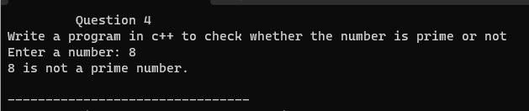

**Question 5. Write a program in c++ to print ‘*’ (Asterisk) in triangle form.**

**Code:**

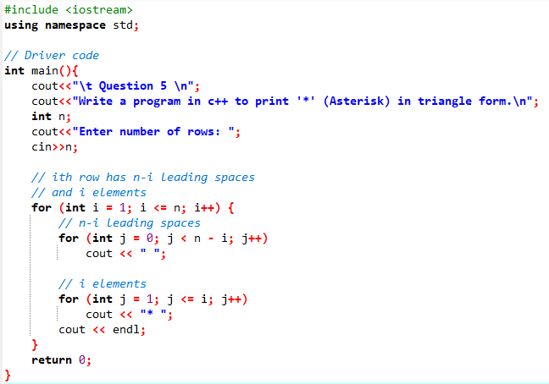

**Output:**

